SEALIFE UK Cold Stunned Sea Turtle Policy
Overview: The UK is seeing a year upon year increase in the number of sea turtles arriving on UK shores. Over the last 200 years, human activities have had a negative effect on their survival with six out of seven species now threatened with extinction.
Turtles aren't well suited to visiting the British Isles. Rarely seen species such as Kemp's Ridley or Hawksbill turtles are usually found after becoming lost during their first migration or getting drawn off course by currents and the weather. Typically we see loggerheads as the main strandings.
When these turtles enter cold waters they become "cold-stunned," which causes them to become lethargic and move increasingly less. They eventually lose the ability to swim, leaving them adrift until they wash up on a beach. Tis typically happens with water temperatures below 12.C
Without help, these turtles can suffer from hypothermia, starvation, and illness, all of which can lead to death.
The health status and medical management of turtles affected by acute versus chronic cold-stunning are often quite different. A grading scale for cold-stunned turtles has been produced, ranging from Class I turtles that are relatively alert and active, to Class IV turtles that are moribund. Acutely cold-stunned turtles are often relatively healthy (i.e., Class I or II) and can recover relatively quickly with appropriate care. Chronically cold-stunned turtles are often affected by severe physiologic derangements and visceral pathology (i.e., Class III and IV) and frequently require intensive medical management over several months of hospitalization.
The below protocol gives an overview or trigae and treatment required for short term and long term care for these animals within our centres before getting them back to the wild at each point veterinary advice should be followed.
Triage:
The strandings network UK https://www.ukturtles.online/ https://ukstrandings.org/ are responsible legally for the initial reporting/ triage of theses animals.
Animals are typically spotted by skippers on boats, dog walkers finding on beach and other members of the public. Typically, they will get in contact with the strandings networks who will begin the triage to the nearest available and willing site. British marine Life Divers https://bdmlr.org.uk/ will typically start the transport and be advised by the strandings network. Once you have agreed the turtle coming to you from the initial triage you will likely be given images and rough idea of sea temperature, measurements. From this point you should contact the IZVG vet on call and begin gaining treatment plan.
Once the Turtle is with you:
Initial Care
You should ensure the animal if has hypothermia(likely) is taken into a climate-controlled room at the assumed temperature of the turtle.
- Internal temperature should be taken- you can use lubricant such as KY jelly to lubricate the cloaca and probe. The probe itself should be a blunted veterinary thermometer which can go below 10.c. https://tinyurl.com/yx78283w The turtle tail should be held straight to prevent issues and inserted (based on turtles size) around 5-10cm inside. Internal temperature will read different from external and the internal temperature should be used to form part of hypothermia treatment.
- External health checks should be taken along with measurements required for the strandings form (Figure 1). When feasible the strandings network should be sent this completed form. The animal(s) should be check for any physical trauma (with pictures thken to be able to send to IZVG) along with full movement of all appendages. The eyes should be check for responsiveness- it is noted below certain temperatures you do not see contractions from the optic nerves due to hypothermia. You should raise the head of the animal to trigger breathing allowing you to check in the mouth for any issues. You should also monitor frequency of breathing also. Body condition should also be assessed and the animal weighed. Anything you find should be relayed to IZVG vets.
*Note* you may think you do not have signs of life. Each site ideally should have a cheap foetal Doppler to detect for life. This can be done using ultra sounds gel put and moved around on the left dorsal neck area- ultra sound solution should not be shaken before use as bubbles inside it may effect result https://tinyurl.com/42fj9b2k
- All of the information gathered previously should be related to the IZVG vet so they can formulate a treatment plan with you. Each case is different so it would not be correct to display here. From there your vet can advise if the animal should be kept in water/not. Note: If a turtle is below 18.C it is to stay dry until it reaches said temperature, in a vat on top of a wet very soft mattress and temperature raised 1-2.C daily maximum depending on what the vet prescribes. Eye to be kept moist several times a day and sprayed twice daily.
- Swim trials- An initial swim trial of variable duration should also be done.But, ONLY until an IZVG vet has instructed you to do so. This would be after the animal has reached 18.C and all flippers are in good order. During this time the animal should be watched carefully to ensure it is able to swim, breath and perform all natural behaviours. Initially this should be done in lower volume of water that can continue to increase dependant on your observations. If you are unsure and have doubt about leaving the animal in water overnight it should be kept dry and at temperature. It is recommended that 24hr viewing cameras are placed in the set up to monitor the animal should a person not be able to be there all day long. Cameras such as nest/google home cameras are great for this.

Secondary Care
Remember the time scale of these events will be advised by the vet. In this process you are advised by IZVG but in practice may need to take the animal to your local vets- ideally, they will have an exotics specialist who would be happy to do this work. It is worth reaching out before you are in this situation.
- Clinical work will need to be done the information from the initial will aid the vet in requesting what should be done. Bloods will need to be obtained from the animal in a dictated timely manner. Bloods will be able to tell a lot about the animal including its hydration needs. Figure 2 is a quick “cheat sheet” on interpreting bloods however this again should always be advised by a vet. Fluid therapy is often provided to cold-stunned turtles based on results of diagnostic testing. The exact nature of fluid therapy may be determined by the vet based on preference, resources, case load, and laboratory results.
- An Xray should be obtained of the animal- this is beneficial for identifying any potential breaks but would also allow visibility for if the animal is showing signs of pneumonia. Three projections are needed, DV, LL, and AP.
- Your vet may also request a CT. Depending on size of the animal you may need to travel further for this.
All imagery should be sent via AHEF to IZVG
Advanced Husbandry Care
This can be referred to as when the animal is “stable” your vet will advise when you are at this stage.
*Note* during all stages biosecurity is important not just for the animal but for your team. The Brighton Biosecurity protocol is listed as Figure 3 as an example.
During this stage we are doing advanced standard husbandry for the animal. A hands off approach should be taken- minimising contact unless necessary not allowing the turtle to associate humans with experiences. Figure 4 give an example of day to day husbandry.
Record keeping is an important part of this whole process- attached is the file Brighton used and ideally this would be what all sites use so data can be pulled together for consensus. Please take time to look through this and reach out should you have any questions.

Enrichment is a large part of getting the turtle ready for release. This should be provided daily and examples and testing are in the case file specifically for Caretta caretta however this can be used for other species. You can find this in the case file.

Nutrition
The vet will advise for when it is the correct time to start feeding the animal. The animal should not be fed at certain temperatures (<18.C). Attached is a diet calculator based on the weight of animal and foods we have at Brighton formulate a diet. This will work in conjunction with the consult from IZVG. Aquavits and calcium powder should also be provided to the animal based on weight. Other forms of diets may be requested. For example, animals <2Kg will be requested a floating mix- floating mix @ 5% BW daily to help it eat. We have listed the contents The following needs to be blended and mixed with gelatin so it will float:1/4 of an aquaminivit tablet; Ca @ 0.25mg/kg; 20% hake (skin removed);25% squid mantel;20% shrimp;30% sardine (without bone or skin);5% spinach; Plus; Spirulina @ 1g/100g of the blend; Salmon Oil @ 0.5ml/100g of the blend. The reason this is as typically these animals are floating and attached to the sargassum and will eat more floating foods. For solid foods you will see in the case files this will auto populate with calories etc. the aim of this model is to better improve the data which can be used in the future.- tong feeding should be avoided as it will increase the human association. You may also be requested to tube feed the animal using Emaraid.

Weight/measurements
These should be taken every 3 days and AHEF updated to ensure the animal has correct growth rate/ progression. This however may be requested more often depending on the specific case

Other Thoughts and Considerations
Inevitably the whole process is very exciting. Should you want any press involvement this should be considered until you are through and in routine of the advanced husbandry care. We hope not. But, things can go wrong and you want to be confident of this before starting that process.

Repatriation
This is a very heavy paperwork process and requires multitude of documentation. It is advised when you are arriving to this point Joe.williams@merlinentertainments.biz or Todd.German@merlinentertainments.biz is approached for support. The vet will advise when you are at the point for release from updating casefile/ AHEF.

Minimum Drugs list
Please see attached minimum drugs list as advised by Tania Monreal to keep in centres with rescue turtles.

Conclusion
Cold-stunning is a natural phenomenon, it could be argued that to be natural selection. Historically, with robust turtle populations, these events were likely not significant with regard to stability or sustainability of populations. The allocation of resources to rehabilitation of cold-stunned turtles can be laboursome and expensive however we are seeing a greater increase in numbers due to a direct influence from climate change . We have a duty of care when it comes to our animal welfare concerns require action to provide humane and compassionate care for these species. These stranding events and associated release events also provide numerous opportunities to educate the public about sea turtles and their conservation status. It should also be noted- there are many people within the company that can support you when caring for a cold stunned turtle. You are not alone and please reach out.

Below are examples from the Brighton facility of simple set up that are effective:
Installed by Nautilus

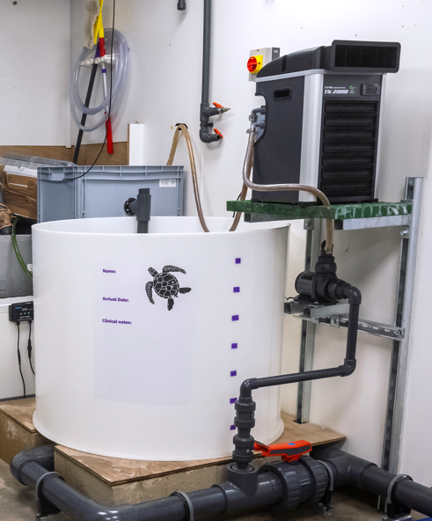
This is a treatment tank
LSS: Chiller heater/ Exter speed adjustable pump, simple tube mechanical filtration (sponge) and bio. Sunrise/set lighting
Should animals need to be kept dry but heated slowly we also use an infra-red heat lamp with a exotera thermostat that can raise air temp slowly. The room is also air conditioned to allow ambient air temp to be low as needed also. This tank is not intended for long term holding.

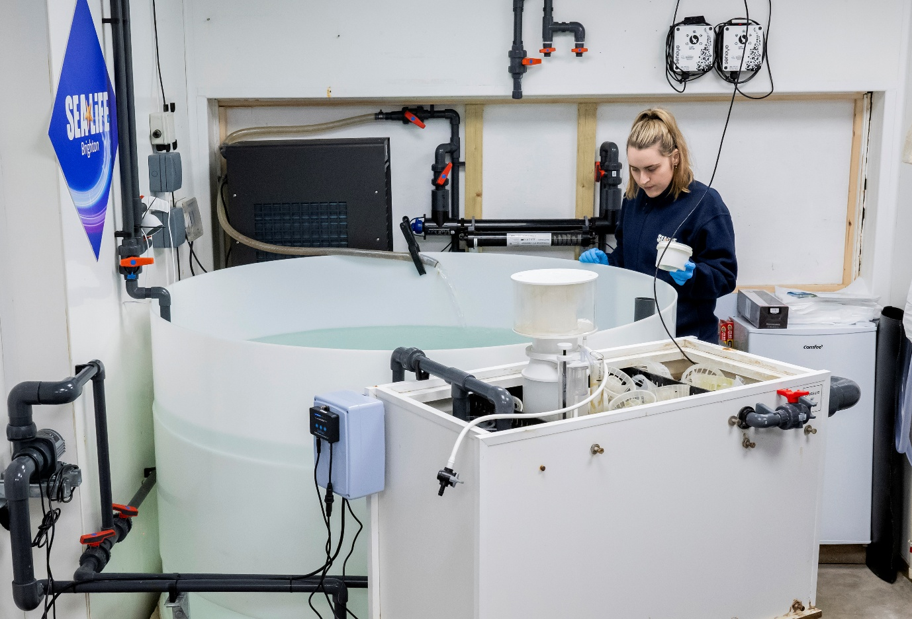
Above is our holding/ reconnaissance tank. This is for longer term holding
LSS: larger Heater/chiller, Sump with bio/protein skimmer, UV Speed adjustable pump Sunrise/set lighting- scope for the addition of UVB also as required.

Storage Tower- We use a storage tower of water that is the maximum capacity minimum of the reconnaissance tank. This has flow through the day and a chiller/heater on it also so can be heated/ chilled to the needed temperature for the hypothermia treatment

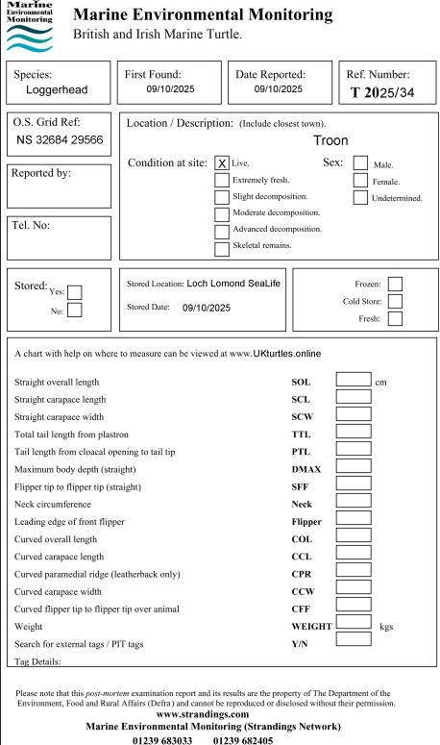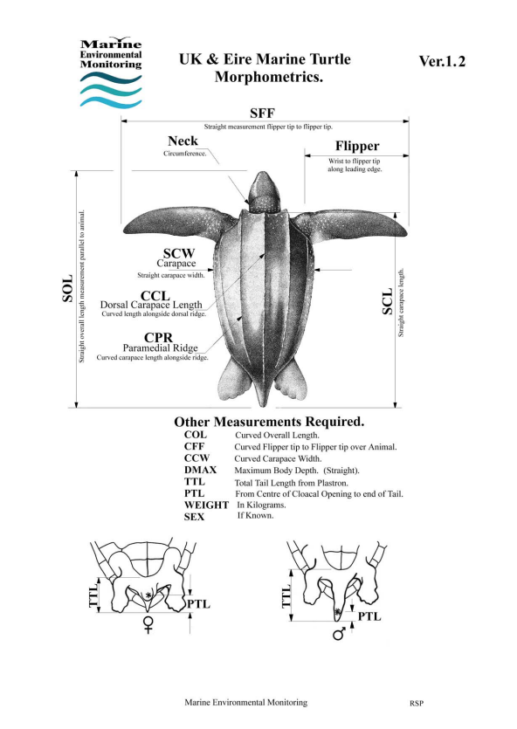
Figure1. Example of Marine Environmental monitroing form

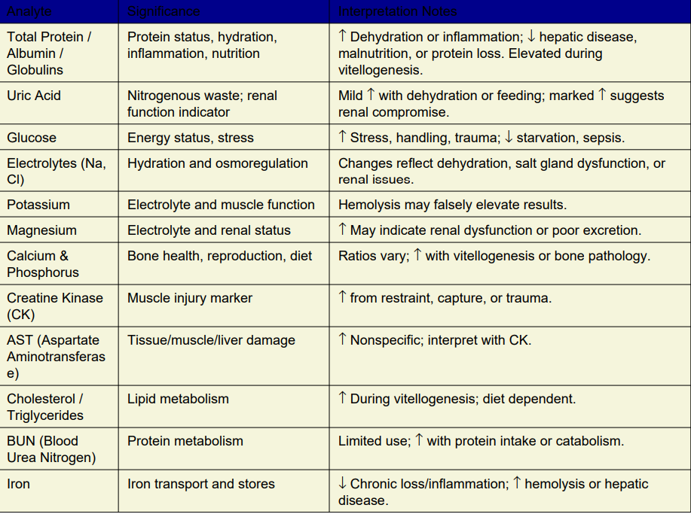
Figure 2- Sea Turtle Bloods cheat sheet- always to be discussed with a vet
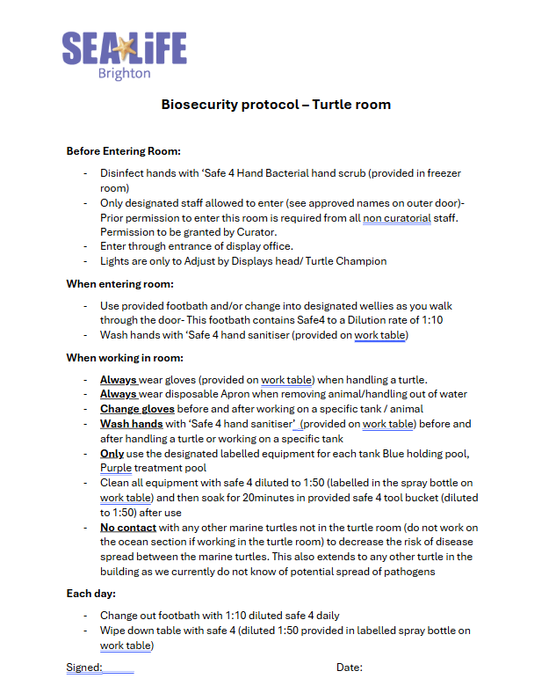
Figure 3- bio security protocol
Figure 4 example of daily palliative husbandry 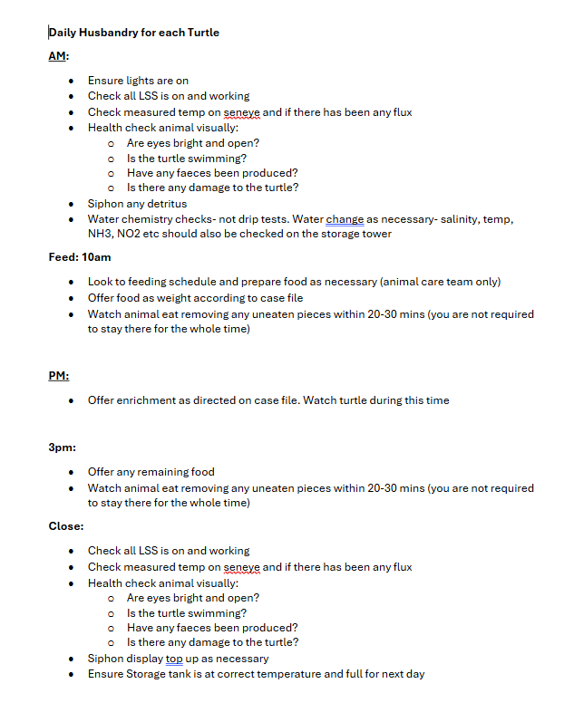
Figure 4- an example of daily palliative husbandry routine

Prescription drugs to have on hand for rescue turtles:
Amikacin
Ceftazidime
Reptile saline (1:1:1 LRS:NaCl0,9%:5%Glucose)
F10 cream and inhalant
Iodine
Chlorhexidine
Silimarine
Ultralevura (Saccharomyces)
Simethicone
Vit K and Vit B12
Aquaminivits
Calcium
Emeraid Carnivore and omnivore

